**Database Term Project**

**Document**

**For**

**Learning Management System**

**Prepared by**

* **2016-CS-122 (Hamza Farooq)**
* **2016-CS-105(Ayesha Atif)**

**Instructor: Sir Samyan Wahla**

**Course: Database Management System**

**Date: 1/05/19**

**Contents**

1. Project Flow Diagrams
   1. Main Page 3
   2. Batches List 4
   3. Create Batch 5
   4. Update Batch 5
   5. Delete Batch 6
   6. Employee List 6
   7. Create Employee 7
   8. Update Employee 7
   9. Delete Employee 8
   10. Assigned courses list 9
   11. Update assigned course 10
   12. Delete assigned course 11
   13. Create Student 12
   14. Edit Student 13
   15. Course index 14
   16. Update Course 14
   17. Delete Course 15
   18. Create Course 16
   19. Semester Course List 16
   20. Add Semester Course 17
   21. Update Semester Course 18
   22. Delete Semester Course 18
   23. Mark Attendance 19
   24. Time Table 20
   25. Preview Timetable 20
   26. Add Course in Time Table 21
   27. Edit Course in Time Table 22
   28. Delete course in Time Table
   29. Add Time Table 23
   30. View Result 24
   31. Result Index 25
   32. Update Result 25
   33. Create Result 25
   34. Delete Result 27
2. List of Actual Features 28
3. List of Completed Features 28
4. Task done by each group member 29
5. PROJECT FLOW DIAGRAMS:
   1. Main Page:

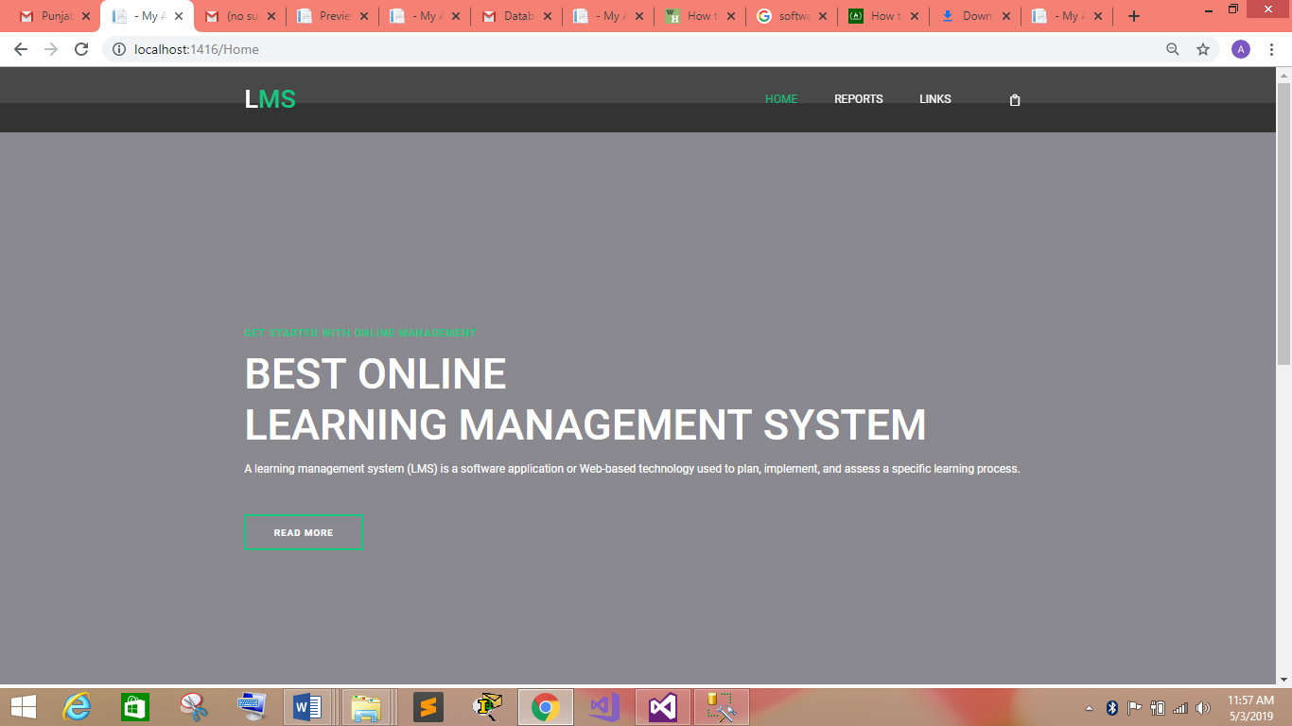

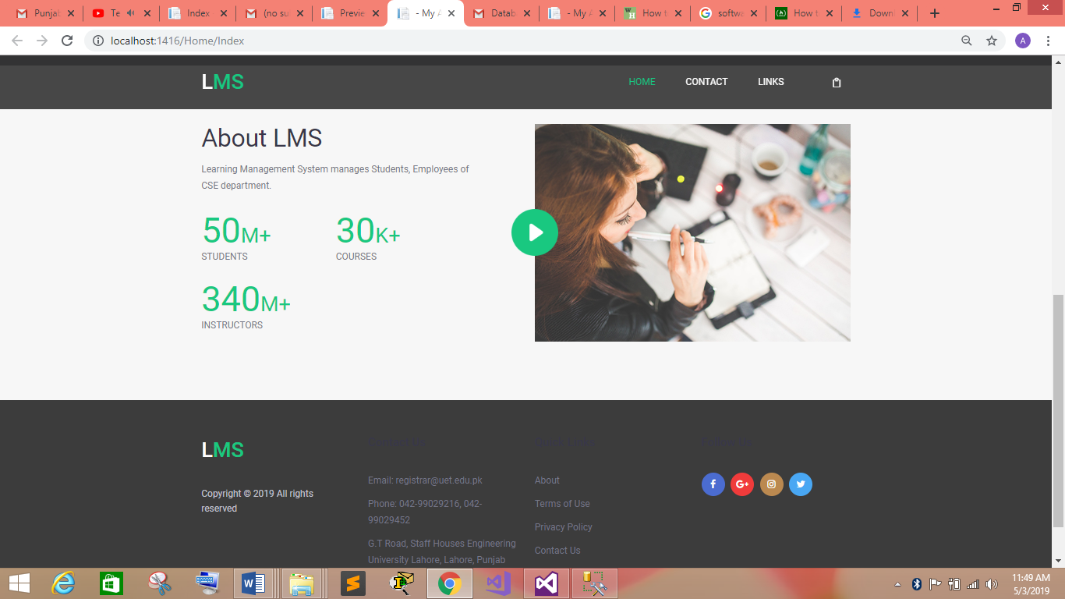

Description:

* Above figures are of main pages from where admin can navigate on different pages.
* Admin can navigate to different pages thorough the link “LINKS” at the header.
* Moreover, reports can be seen on clicking the link of the reports.
  1. Batches List

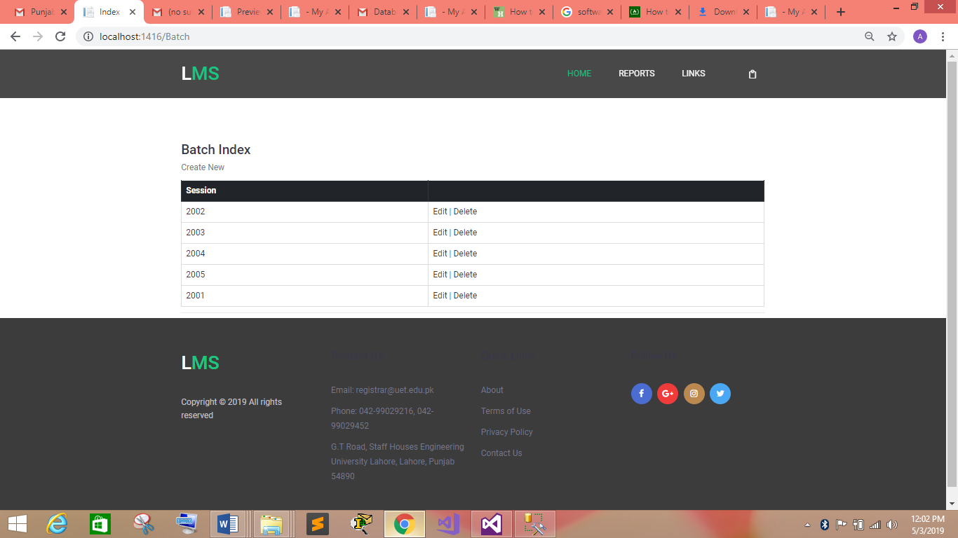

Description:

* Above figures is of Batches list.
* After Clicking on the LINKS and then Batches in the dropdown list admin can access this page.
* Database table “Batch” is used here to show the list of batches.
  1. Create Batch

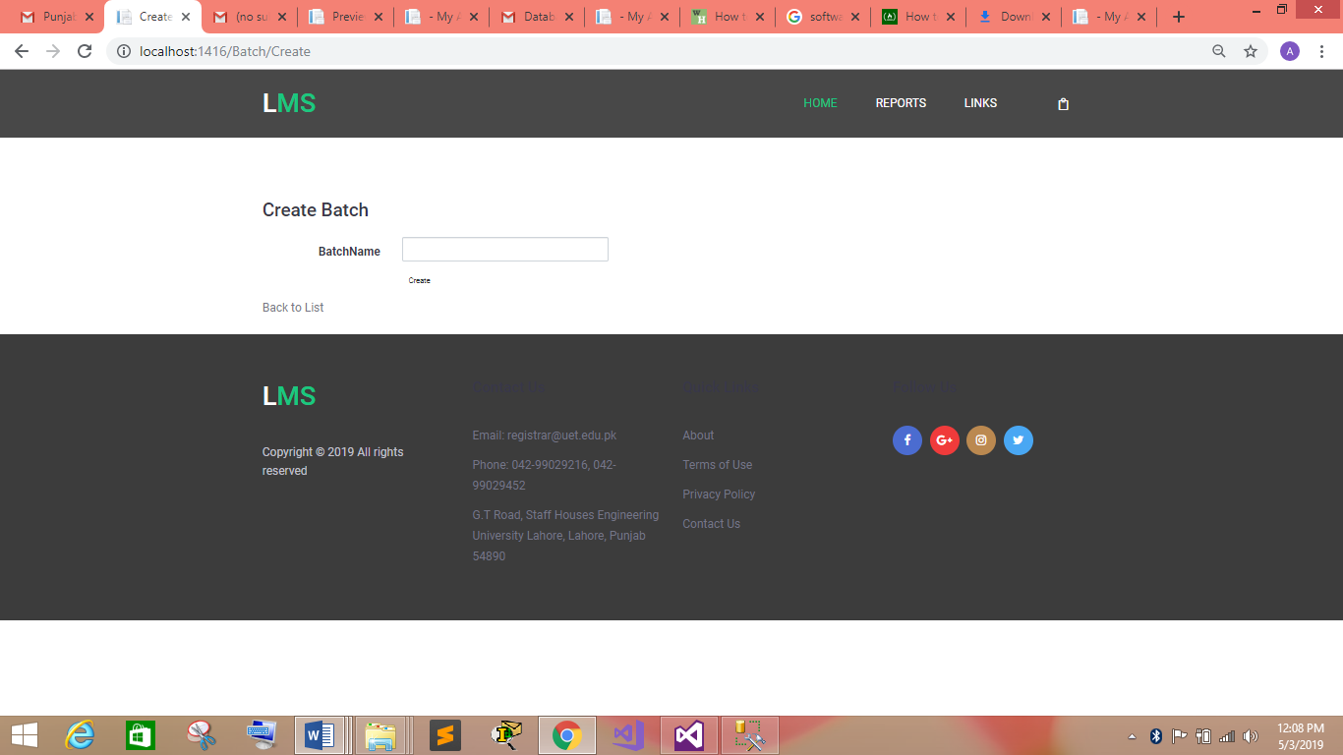

Description:

* Above figures is of create batch/Add batch in the database.
* After clicking on create new link on the Batch index page admin can navigate to this page.
* Database table “Batch” and “Semester” are used here to add the batch and semesters of each batch (which are auto generated) in the database.
  1. Update Batch

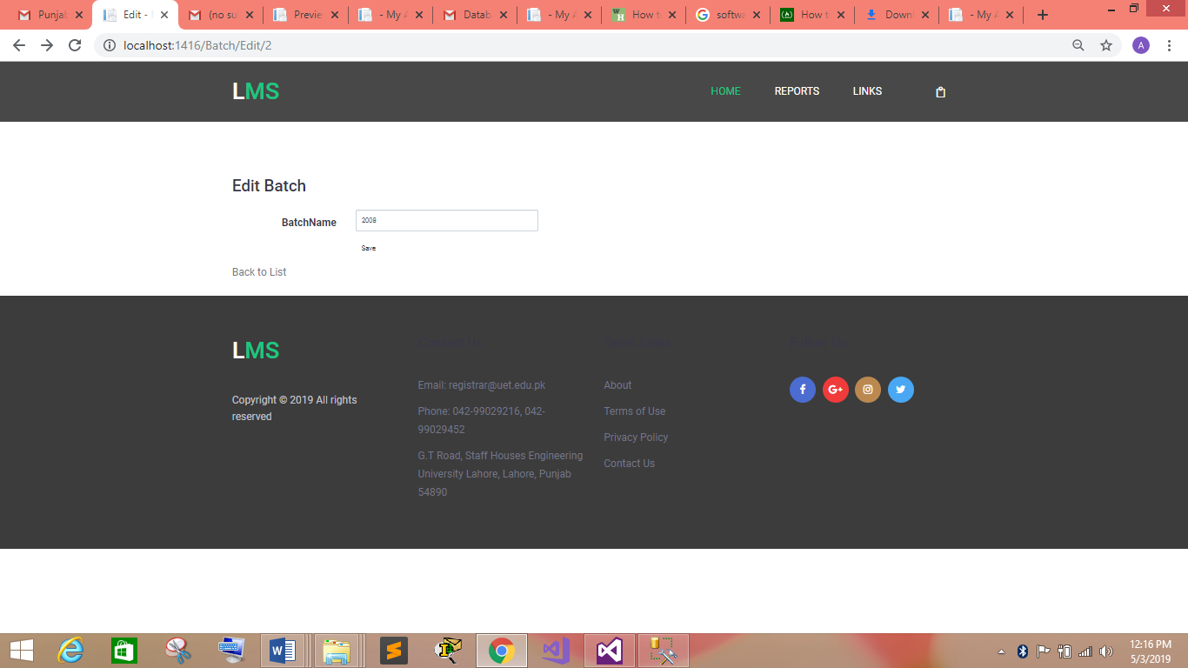

Description:

* Above figures is of update batch in the database.
* After clicking on Edit link on the Batch index page admin can navigate to this page.
* Database table “Batch” is used here to update the batch.
  1. Delete Batch

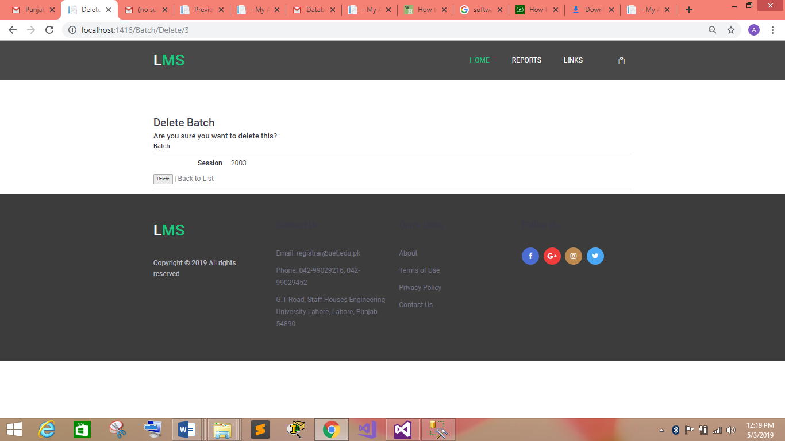

Description:

* Above figure is of Delete batch from the database.
* After clicking on Delete link on the Batch index page admin can navigate to this page.
* Database table “Batch” is used here to delete the batch.
  1. Employee List:

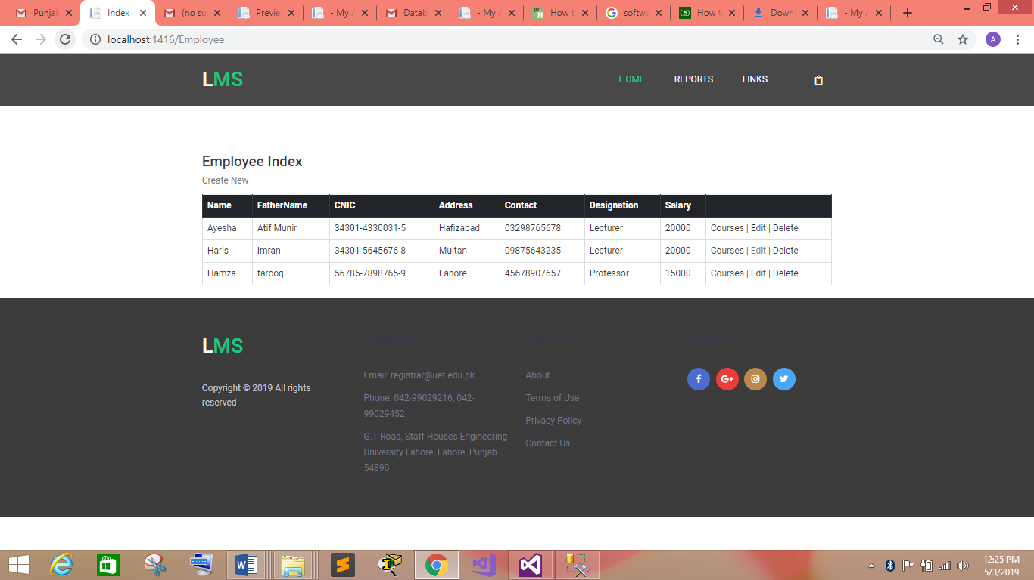

Description:

* Above figure is of Employee list.
* After clicking on the LINKS and then Employee in the dropdown list at the main page header admin can access this page.
* Database tables “Employee” and “Person” are used here to show the list of all employees.
  1. Create Employee

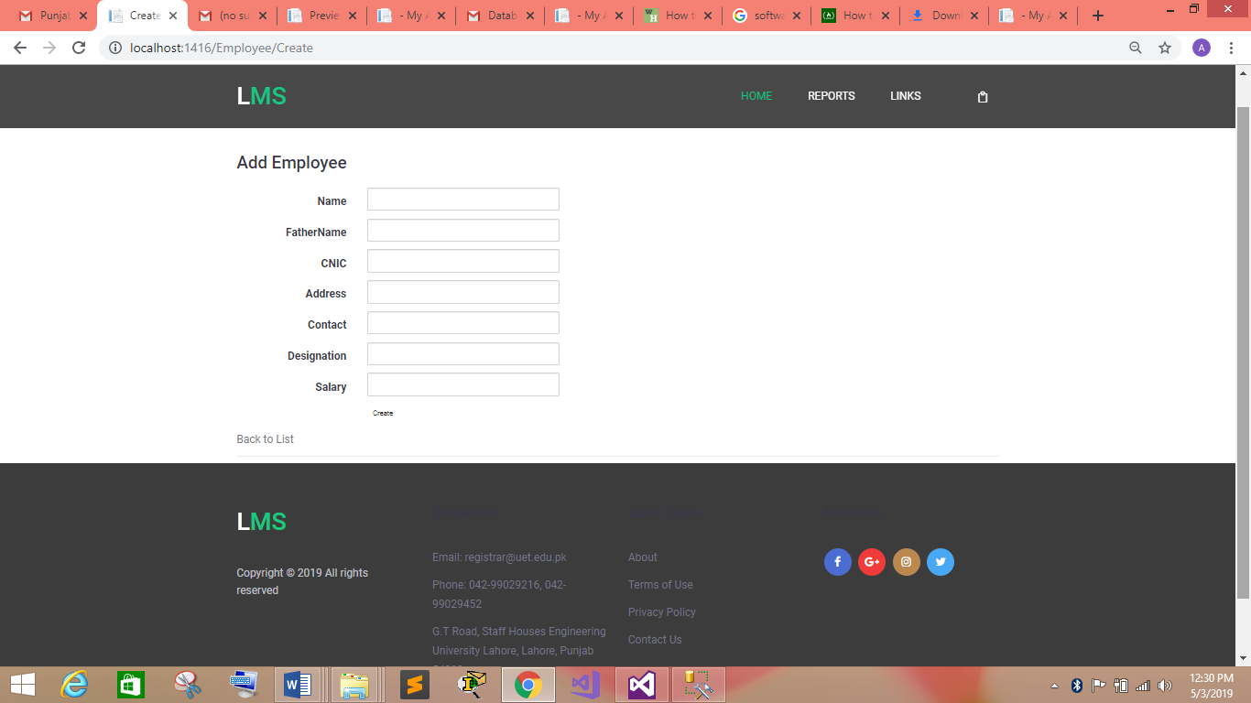

Description:

* Above figure is of create Employee/Add Employee in the database.
* After clicking on create new link on the Batch index page admin can navigate to this page.
* Database table “Employee” and “Person” are used here to add the employee details in the database.
  1. Update Employee

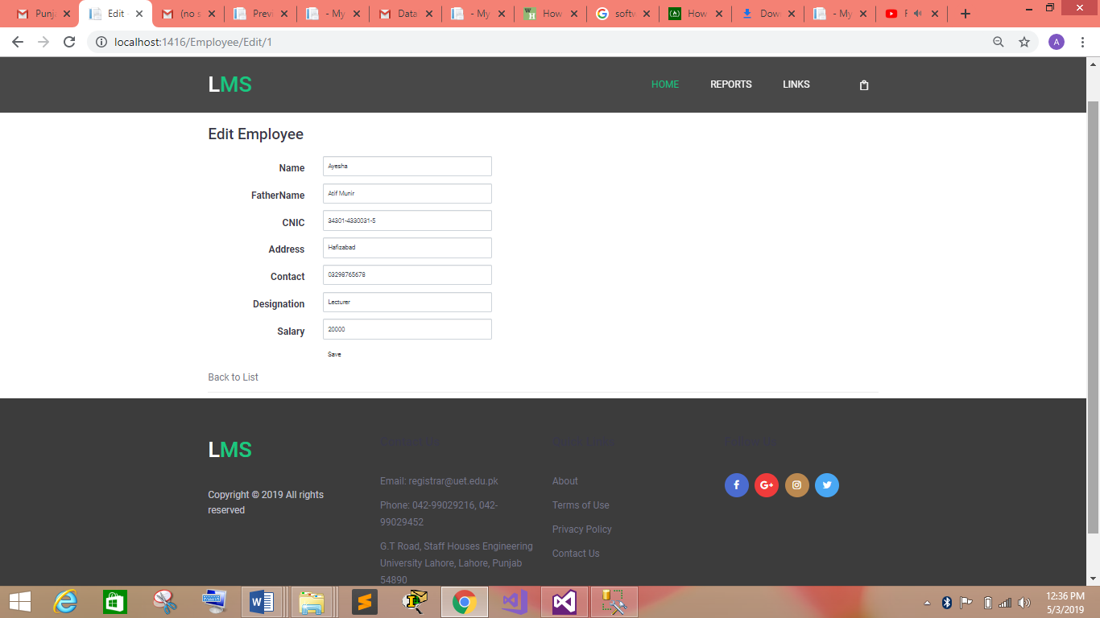

Description:

* Above figure is of update employee in the database.
* After clicking on Edit link on the employee index page admin can navigate to this page.
* Database table “Employee” and “Person” are used here to update the employee.
  1. Delete Employee

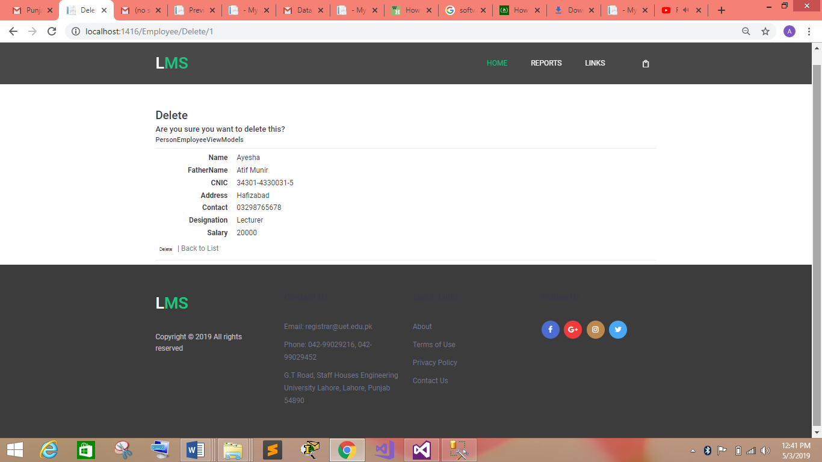

Description:

* Above figure is of Delete Employee from the database.
* After clicking on Delete link on the Employee index page admin can navigate to this page.
* Database tables “Employee” and “Person” are used here to delete the batch.
  1. Assigned Courses List

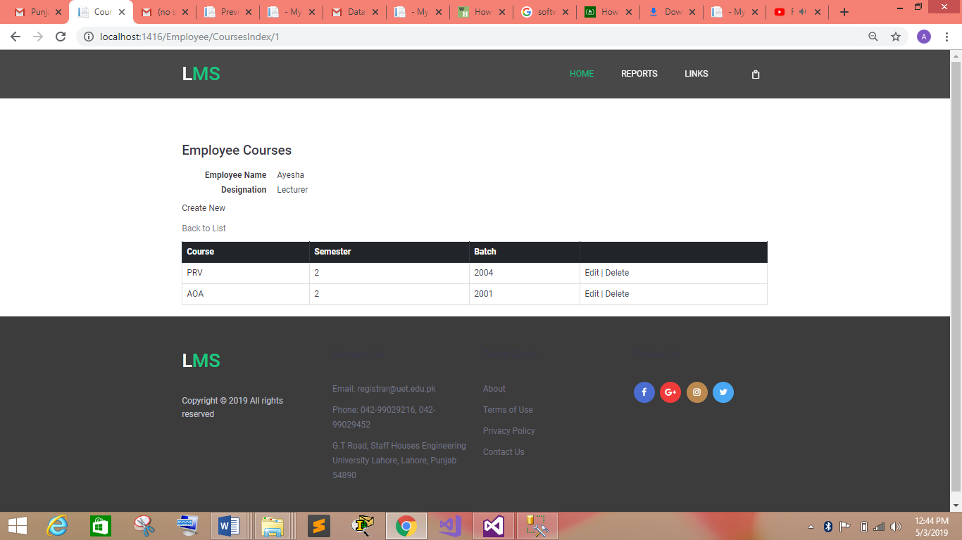

Description:

* Above figure is of list of courses assigned to the employee.
* After clicking on the courses in the employee index page admin can access this page.
* Database tables “Employee”, “Course”, “Batch”, “Semester” and “Person” are used here to show the list of assigned courses to the employee.
  1. Assign Courses

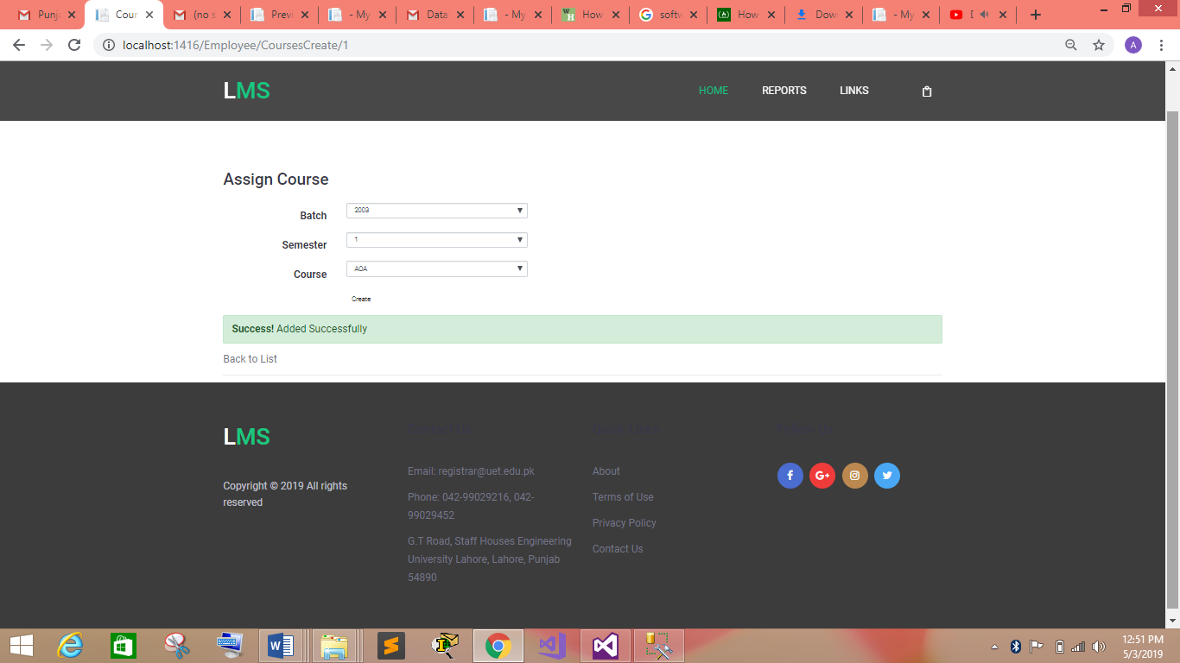

Description:

* Above figure is to assign course to the employee.
* After clicking on the create new in the Employee Courses index page admin can access this page.
* Database tables “Employee”, “Course”, “Batch”, “Semester” and “Person” are used here to show the list of assigned courses to the employee.
  1. Update Assigned Courses

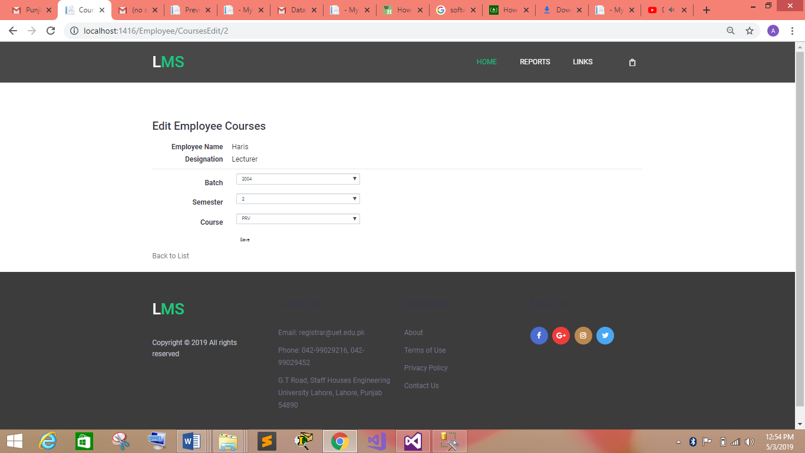

Description:

* Above figure is to update assigned course to the employee.
* After clicking on the Edit in the Employee Courses index page admin can access this page.
* Database table “EmployeeCourseSemester_MTM” is used here to show the list of assigned courses to the employee.
  1. Delete Assigned Courses

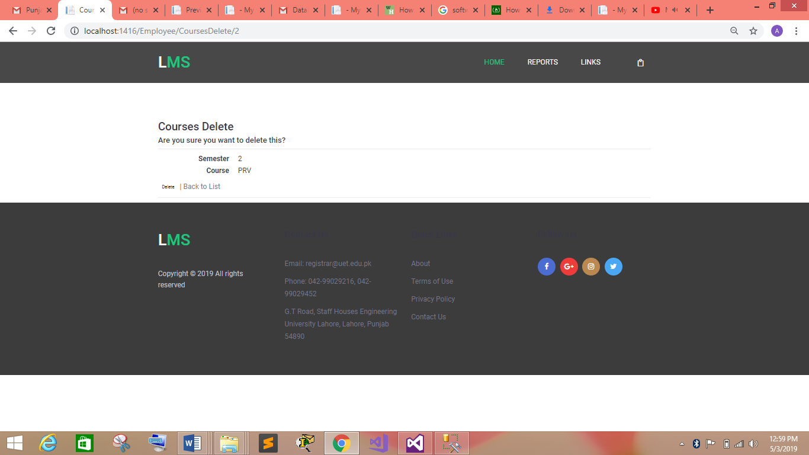

Description:

* Above figure is to delete assigned course to the employee.
* After clicking on the Delete in the Employee Courses index page admin can access this page.
* Database table “EmployeeCourseSemester_MTM” is used here to delete the list of assigned courses to the employee.
  1. Students List

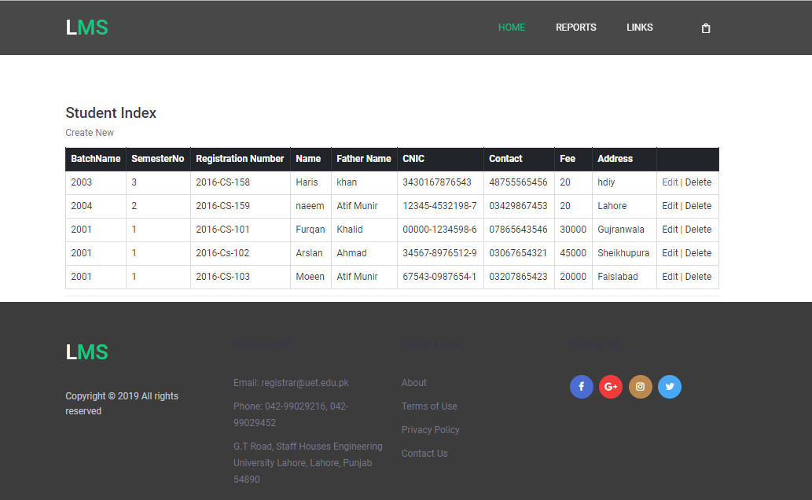

Description:

* Above figure is of Student list.
* After clicking on the LINKS and then Students in the dropdown list at the main page header admin can access this page.
* Database tables “Student”, “Batch”, “Semesters” and “Person” are used here to show the list of all employees.
  1. Create Student

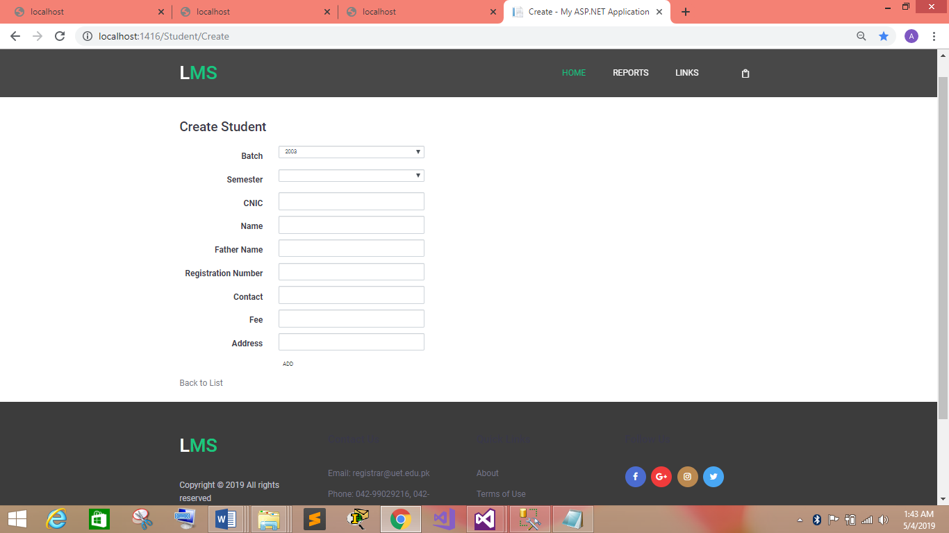

Description:

* Above figure is of create Student/Add Student in the database.
* After clicking on create new link on the Student index page admin can navigate to this page.
* Database table “Student”, “Batch”, “Semesters” and “Person” are used here to add the employee details in the database.

* 1. Edit Student

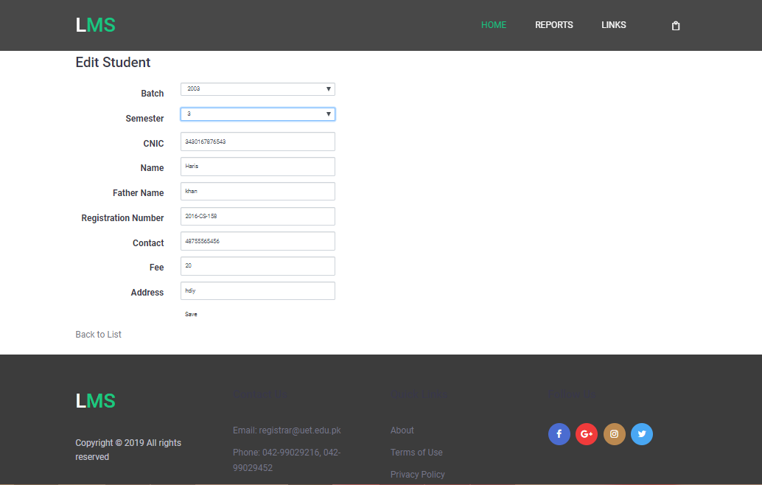

Description:

* Above figure is of update Student in the database.
* After clicking on Edit link on the Student index page admin can navigate to this page.
* Database table “Student” and “Person” are used here to update the employee.
  1. Courses Index

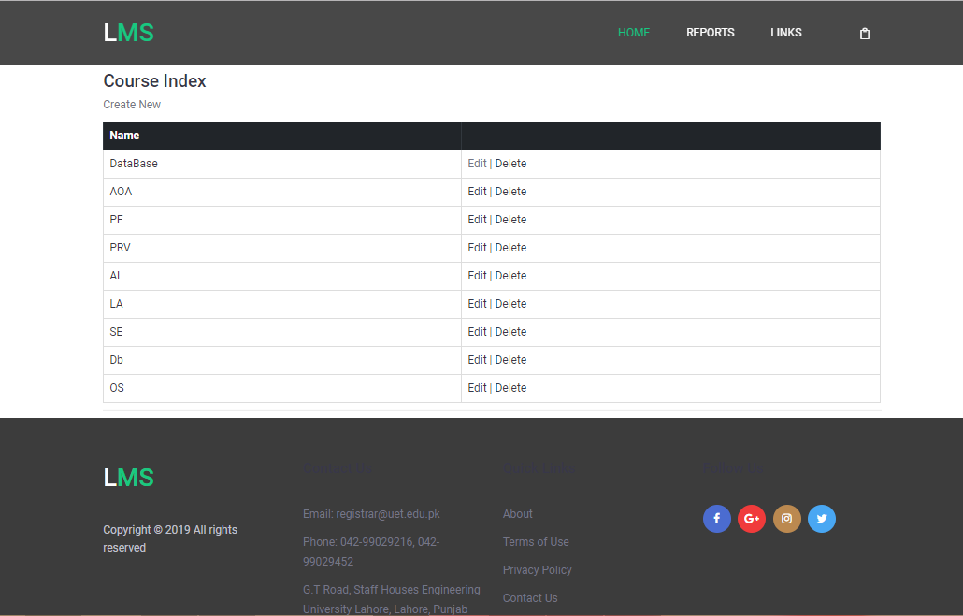

Description:

* Above figure is list of courses.
* After clicking on the LINKS and then Course in the dropdown list at the main page header admin can access this page.
* Database table “Course” is used here to show the list of all employees.
  1. Update Course

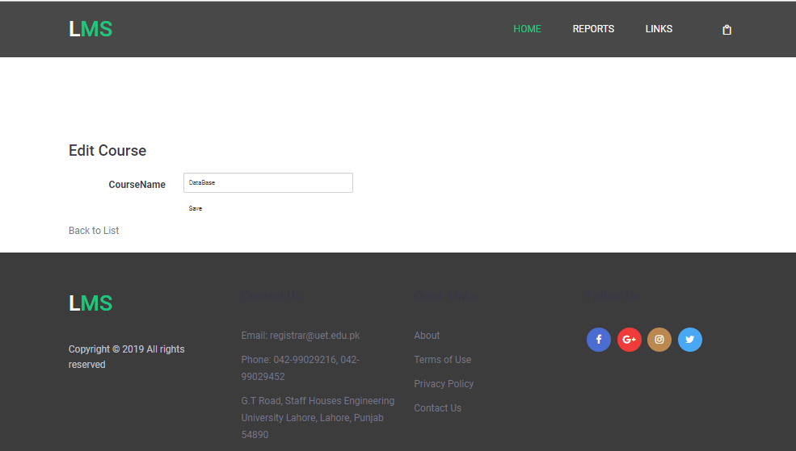

Description:

* Above figure is of update course in the database.
* After clicking on Edit link on the course index page admin can navigate to this page.
* Database table “Course” are used here to update the employee.
  1. Delete Course

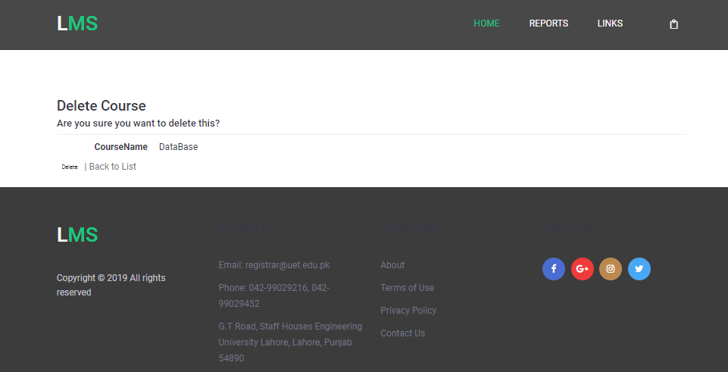

Description:

* Above figure is to delete course from the database.
* After clicking on the Delete in the Courses index page admin can access this page.
* Database table “Course” is used here to delete the list of courses.
  1. Create Course

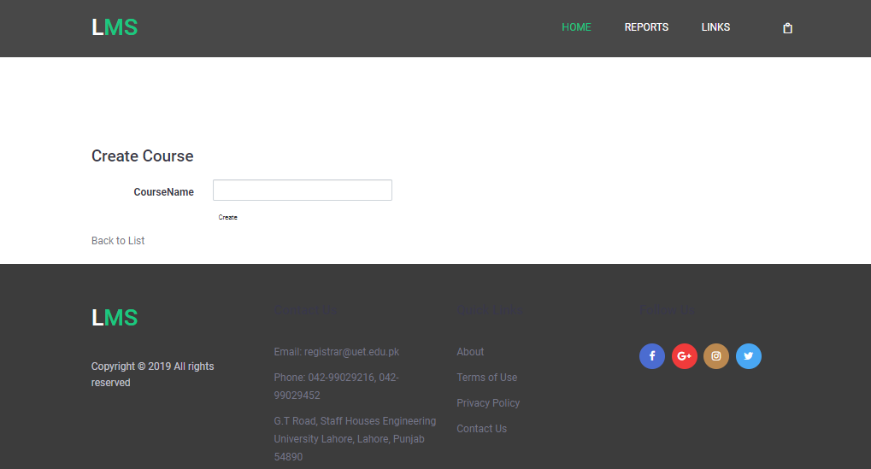

Description:

* Above figure is of create Course/Add Course in the database.
* After clicking on create new link on the course index page admin can navigate to this page.
* Database table “Course” is used here to add the Course details in the database.
  1. Semester Courses List

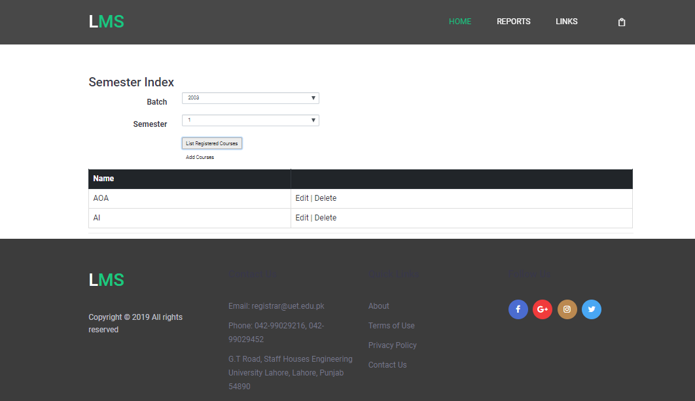

Description:

* Above figure is list of courses assigned to a semester.
* After clicking on the LINKS and then Semester in the dropdown list at the main page header admin can access this page.
* Database tables “Course”,” Semester” and “CourseSemester_MTM” are used here to show the list of all courses of a semester.
  1. Add Semester Courses

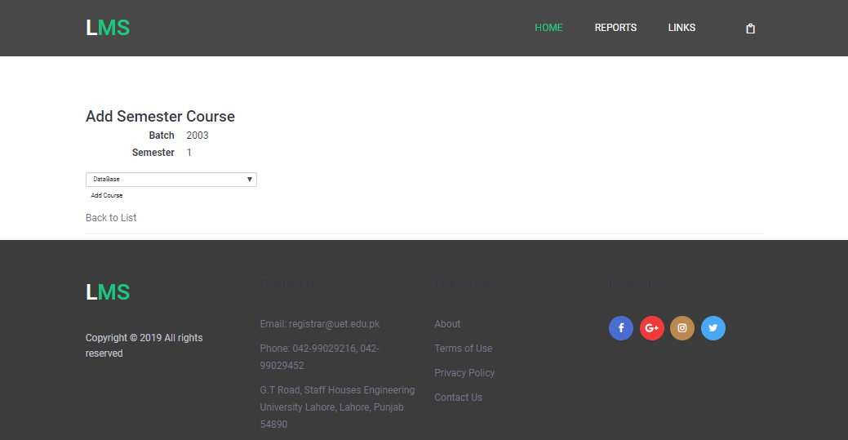

Description:

* Above figure is of Assign Course to a semester .
* After clicking on Add course button on the Semester Course index page admin can navigate to this page.
* Database tables “Course”, “Semester” and “CourseSemester_MTM” are used here to add the Course details in the database.
  1. Update Semester Courses

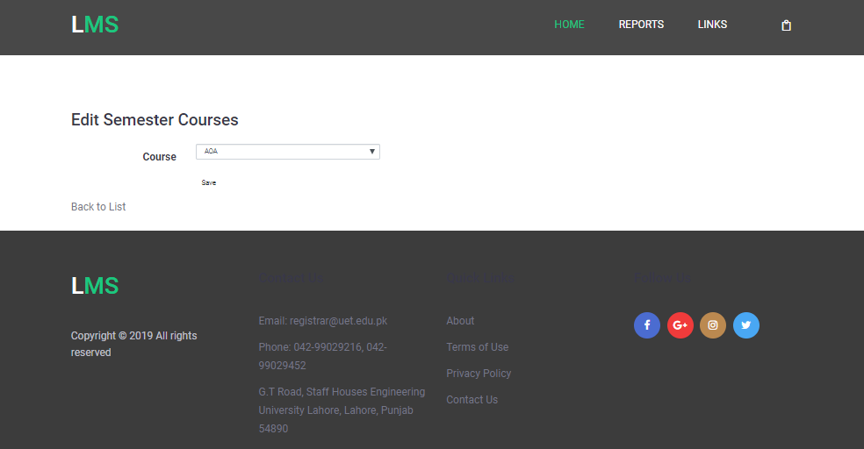

Description:

* Above figure is of update assigned courses of a semester .
* After clicking on edit link on the Semester Course index page admin can navigate to this page.
* Database table “CourseSemester_MTM” is used here to update the Course details in the database.
  1. Delete Semester Courses

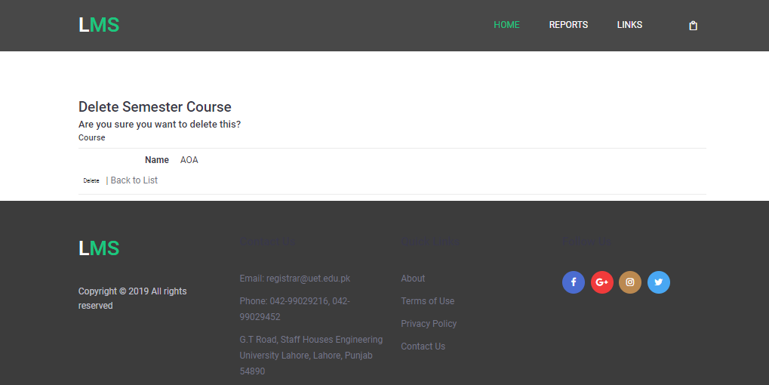

Description:

* Above figure is to delete assigned courses of a semester .
* After clicking on delete link on the Semester Course index page admin can navigate to this page.
* Database table “CourseSemester_MTM” is used here to delete the Course details in the database.
  1. Mark Attendance

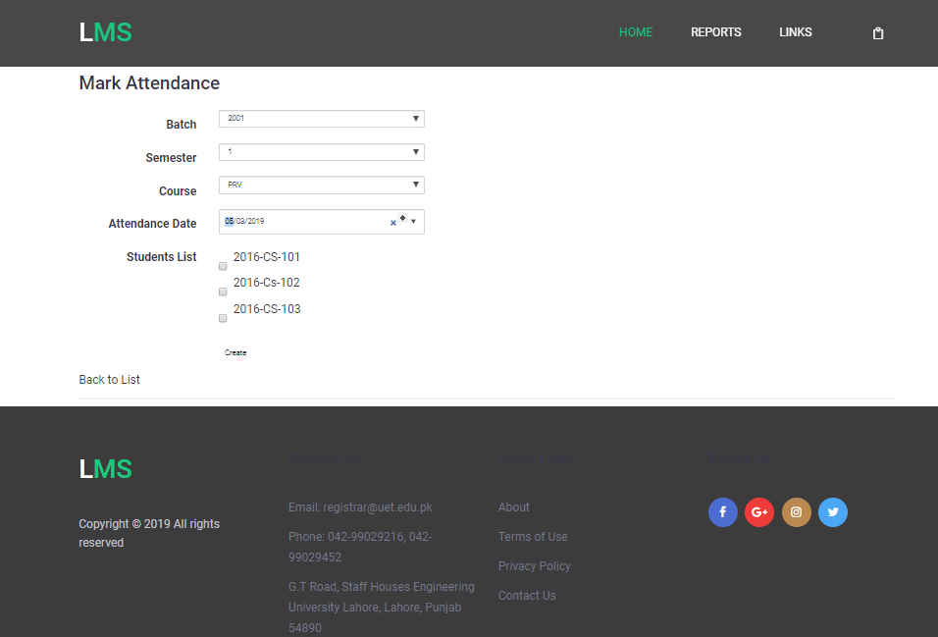

Description:

* Above figure is to mark attendance of students of a course.
* After clicking on the LINKS and then Attendance in the dropdown list at the main page header admin can access this page.
* Database tables “Batch”,” Semester” and “CourseSemester_MTM”, “Attendance” and “Student” are used here to mark the attendance.
  1. Time Table

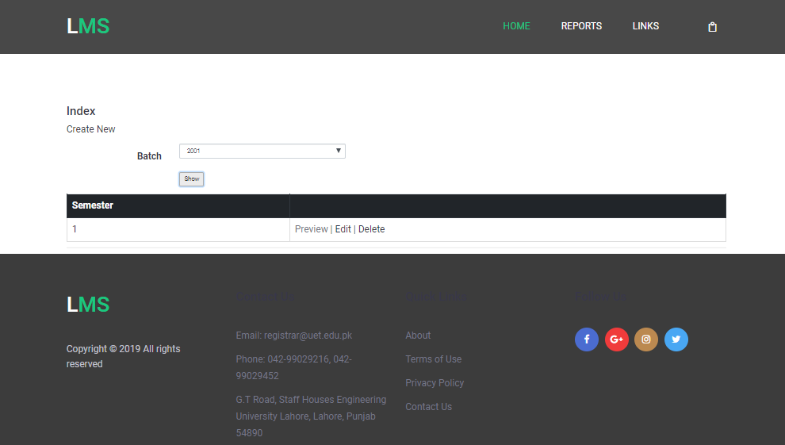

Description:

* Above figure is to select batch and semester of which admin want to preview the time table.
* After clicking on the LINKS and then time table in the dropdown list at the main page header admin can access this page.
* Database tables “Batch”, “TimeTable” and ” Semester” are used here.
  1. Preview Time Table

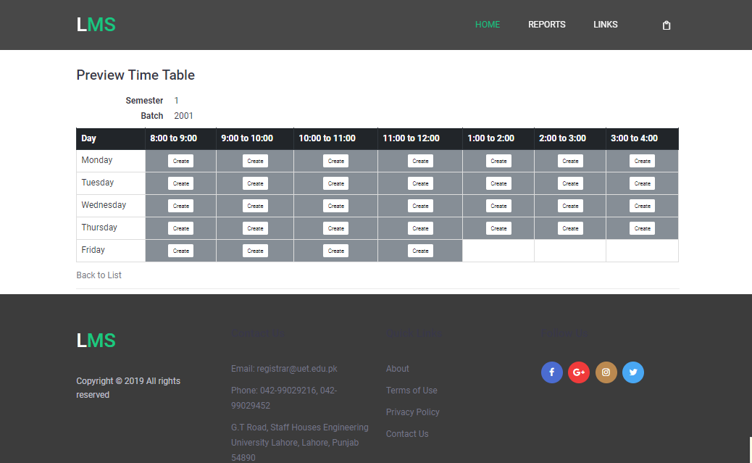

Description:

* Above figure is to preview the time table.
* After clicking on the preview links admin can access this page.
* Database tables “Batch” and ” Semester” are used here.
  1. Add Course In Time Table

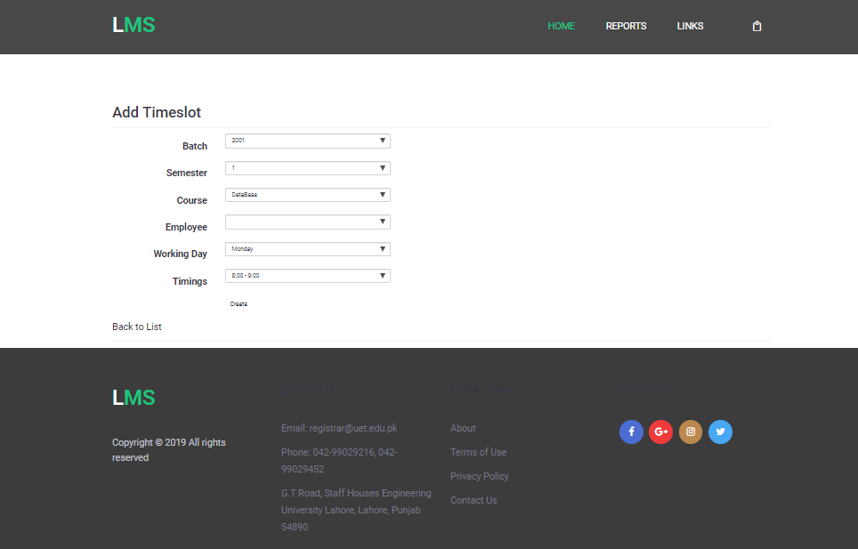

Description:

* Above figure is to add course on particular timeslot in the time table.
* After clicking on the create button in the preview timetable admin can access this page.
* Database tables “Batch” and ” Semester”, “EmployeeCourseSemester_MTM”, “Person”, “Employee”, “WorkingDays”, “TimetableSlot”, “TimetableTimeslot_MTM” and “TimeTable” are used here.
  1. Edit Course in Time Table

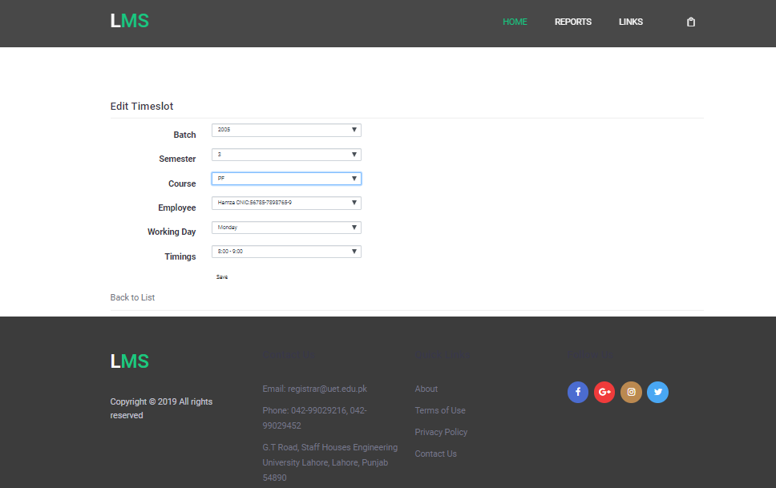

Description:

* Above figure is to Edit course on particular timeslot in the time table.
* After clicking on the edit button in the preview timetable admin can access this page.
* Database tables “Batch” and ” Semester”, “EmployeeCourseSemester_MTM”, “Person”, “Employee”, “WorkingDays”, “TimetableSlot”, “TimetableTimeslot_MTM” and “TimeTable” are used here.
  1. Add Time Table

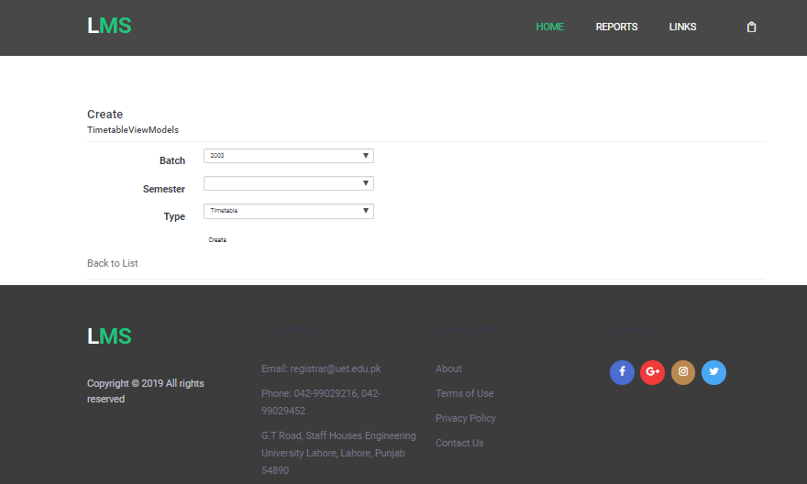

Description:

* Above figure is to select batch and semester of which admin want to preview the time table.
* After clicking on the create new link on the Timetable index page admin can access this page.
* Database tables “Batch”, “TimeTable” and ” Semester” are used here.
  1. Delete Course in Time Table

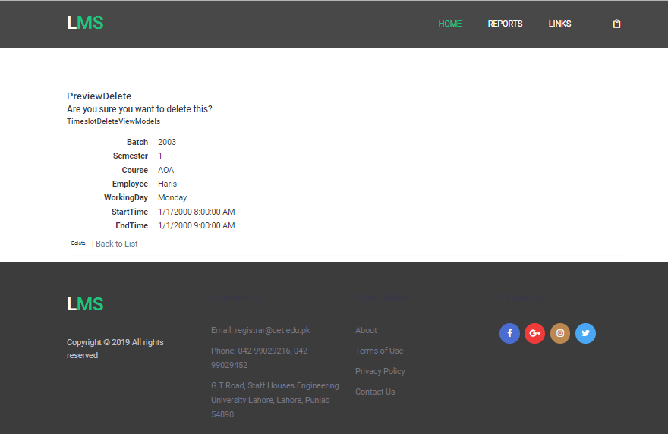

Description:

* Above figure is to delete course from the time table.
* After clicking on the delete link on the preview Timetable admin can access this page.
* Database tables “Batch” and ” Semester”, “EmployeeCourseSemester_MTM”, “Person”, “Employee”, “WorkingDays”, “TimetableSlot”, “TimetableTimeslot_MTM” and “TimeTable” are used here.
  1. View Result

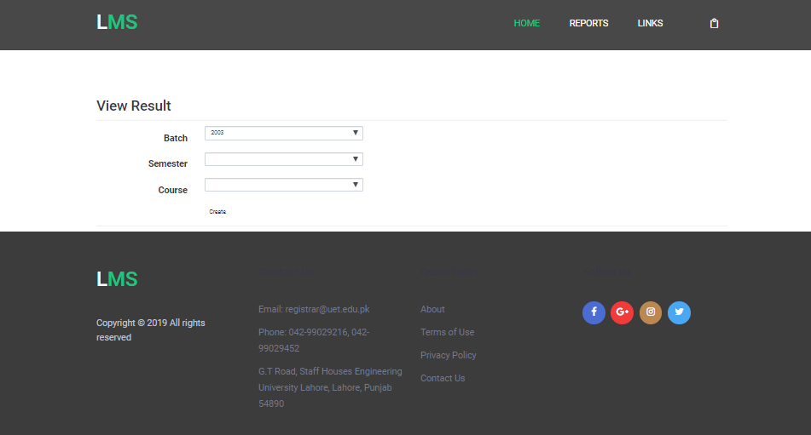

Description:

* Above figure is to view result a course of particular semester
* After clicking on the LINKS and then Result in the dropdown list at the main page header admin can access this page.
  1. Result Index

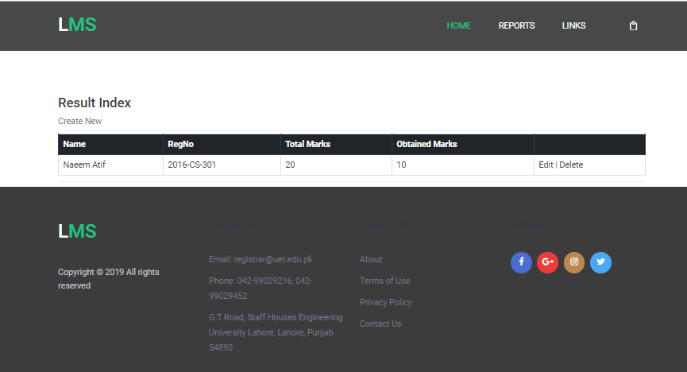

Description:

* Above figure is to view result a course selected in previous view i.e. View Result.
* After clicking on the create at View Result view admin can access this page.
* Database table “CourseSemester_MTM”, “Person”, “Student” and “Result” tables are used to show list of students along with their marks details.
  1. Update Result

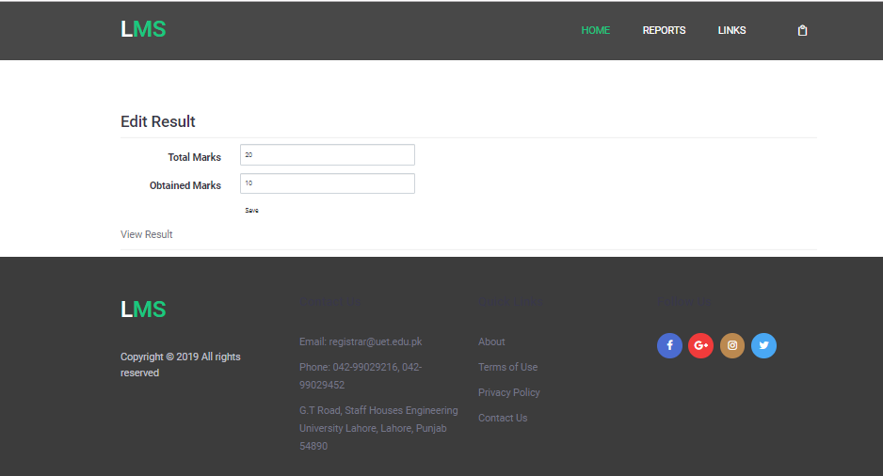

Description:

* Above figure is to update result .
* After clicking on the edit link at Result Index view admin can access this page.
* Database table “Result” is used to update the marks details.
  1. Create Result

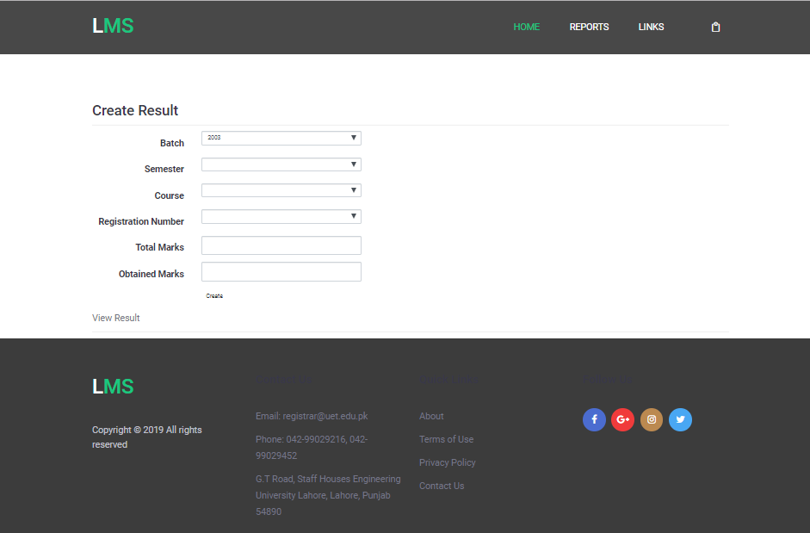

Description:

* Above figure is to add result details of student..
* After clicking on the create new link at View Result view admin can access this page.
* Database table “Result” and “CourseSemester_MTM” is used to Add result details of a student in a particular course.
  1. Delete Result

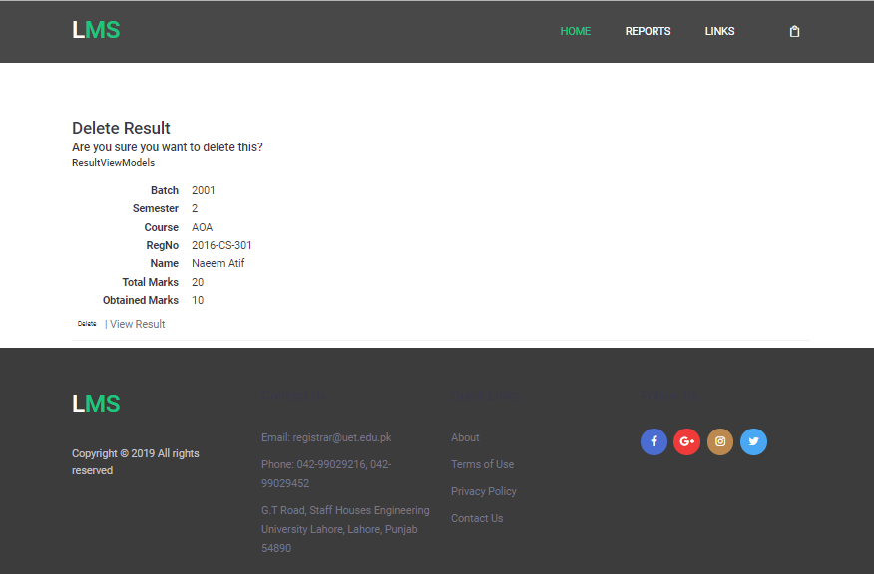

Description:

* Above figure is to delete result details of student..
* After clicking on the delete link at Result Index view admin can access this page.
* Database table “Result” , “Semester”, “Batch”, “Person” and “CourseSemester_MTM” is used to delete result details of a student in a particular course.

1. List of actual features:

* Admin can Add, View, edit and delete Batches.
* Admin can Add, view, edit, delete students.
* Admin can Add, view, edit, delete Employee.
* Admin can Add, view, edit, delete courses.
* Admin can assign courses to employees, view courses, edit courses and delete courses.
* Admin can assign courses to semester., view courses, edit courses and delete courses.
* Admin can add, view, edit and delete timetable of each semester of each batch.
* Admin can add, view, edit and delete result of student in each courses of enrolled semester.
* Admin can mark attendance.
* Admin can create, view, edit and delete date sheet.
* Admin can view institution detail i.e. contact number, email, location etc.

1. List of completed features:

Following is the list of completed features.

* Admin can Add, View, edit and delete Batches.
* Admin can Add, view, edit, delete students.
* Admin can Add, view, edit, delete Employee.
* Admin can Add, view, edit, delete courses.
* Admin can assign courses to employees, view courses, edit courses and delete courses.
* Admin can assign courses to semester., view courses, edit courses and delete courses.
* Admin can add, view, edit and delete timetable of each semester of each batch.
* Admin can add, view, edit and delete result of student in each courses of enrolled semester.
* Admin can mark attendance.
* Admin can view institution detail i.e. contact number, email, location etc.

1. Task completed by each member:
2. Hamza Farooq:

* CRUD implementation of time table.
* CRUD implementation of Courses.
* CRUD implementation of Batches.
* Assigned courses to each semester.
* CRUD implementation of Assigned course to semester.
* Front End Designing of above modules.
* Theme integration.
* Validation of above modules.
* Testing of above modules.

1. Ayesha Atif:

* CRUD implementation of Students.
* CRUD implementation of Employee.
* Assigned courses to each employee.
* CRUD implementation of assigned courses to each employee.
* CRUD implementation of Result.
* Mark Attendance.
* Testing of above modules.
* Validation of above modules.
* Front End designing of above modules along with main page.